County Councillor Update  Coker Division SCC  Cllr Mark Keating  January 2020 |  | 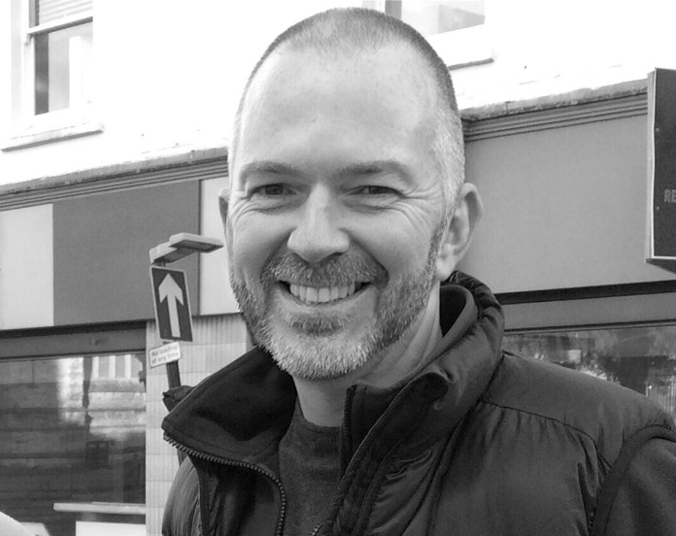
Representing you at Somerset County Council - Barwick, Chiselborough, Closworth, East Chinnock, East Coker, Hardington Manderville, Hardington Marsh, Hardington Moor, Haselbury Plucknett, Middle Chinnock, Montacute, North Coker, North Perrott, Norton Sub Hamdon, ​Odcombe, Pendomer, Sutton Bingham, Stoford, West Chinnock, West Coker.
Useful Contacts Resources and Websites
Cllr Mark Keating – Somerset County Council | E: MAKeating@Somerset.gov.uk | M: 07767 203968
South Somerset Area Highways Office | E: countyroads-southsom@somerset.gov.uk | T: 0300 123 2224
Report Pothole/Road Defect | E: roadsandtransportSD@somerset.gov.uk | T: 0300 123 2224
Report Dead Animal/Mud on Road | E: roadsandtransportSD@somerset.gov.uk | T: 0300 123 2224
Neil McWilliams – Highways Service Manager | E: countyroads-southsom@somerset.gov.uk | T: 0300 123 2224
Lee Norman – Assist Highways Service Manager | E: countyroads-southsom@somerset.gov.uk | T: 0300 123 2224
Garry Warren – Traffic Engineer. Traffic & Transport Development | E: countyroads-southsom@somerset.gov.uk | T: 0300 123 2224
Gully Emptying / Road Sweeper | E: chris.holley@southsomerset.gov.uk | T: 01935 462462
Nick Allen – SSDC Ranger Scheme | E: nick.allen@southsomerset.gov.uk | T: 01935 462462
Road Records & Highway Licensing | E: Roadrecords@Somerset.gov.uk | T: 0300 123 2224

Report Adult at Risk | adults@somerset.gov.uk |  |  | T: 0300 123 2224  T: Emergency: 999
Report Child at Risk | childrens@somerset.gov.uk |  |  | T: 0300 123 2224  T: Emergency: 999
Children’s Social Care Worker out of hours Emergency Duty Team |  |  |  | T: 0300 123 2327
Fostering and Adoption www.fosteradoptsomerset.org.uk | AandFRecruitmentEnquiryLine@somerset.gov.uk |  |  | T: 0800 587 9900
www.somersetwaste.gov.uk |  | ssdc@southsomerset.gov.uk | T: 01935 462462
https://www.travelsomerset.co.uk/ |  | Travel - Drive Bus Train Walk Cycle Weather
www.somerset.gov.uk |  | generalenquiries@somerset.gov.uk | T: 0300 123 2224
http://roadworks.org/ |  | Useful website for road works info
www.facebook.com/somersetcountycouncil |  | Somerset County Council Facebook page
https://roam.somerset.gov.uk/roam/map |  | Interactive Rights of Way Map / maintenance reporting
My January update is as follows, but I’d like to take this opportunity to wish everyone a healthy, happy and productive New Year.
The Leader of Somerset County Council has hailed a ‘remarkable’ financial turnaround as a strategy for the next three years is published. It comes as an independent report into Local Authority performance placed Somerset in the top 10 for most improved councils. Leader of the Council, Cllr David Fothergill, was positive in his assessment of Somerset’s financial future ahead of Wednesday’s Cabinet meeting which will discuss the County Council’s three-year financial strategy. He said: “We no longer have a financial crisis and are on our way to the financial stability all local authorities are striving for. To be looking to the next financial year without the shadow of additional savings is truly remarkable.”
The three-year strategy highlights factors underpinning the turnaround, including tough decisions in the past, a tight grip on spending and additional Government funding. Together these mean the authority is forecasting that a balanced budget can be set next year without the need for any additional savings or reductions to frontline services. The strategy also includes increasing reserves and an intention to invest in improving key adults and children’s services.
Cllr Fothergill, said: “The pressure on local authority finances have been huge in recent years and, like many councils, we have been through some very tough times. This turnaround reflects the hard work of our staff, partners and communities – it is really humbling to be in this position and testament to how far we have come. “But we must be cautious, too much of this authority’s funding is uncertain and we need to strengthen reserves and make measured investment to improve lives.”
Last month Somerset made it into the top ten most improved local authorities in the annual Impower ‘Which councils are best?’ report. In September the Council’s auditor recognised its strengthened finances by giving it an improved Value For Money rating and commenting on its progress and ‘positive trajectory’. Cllr Fothergill said: “We are doing great work to improve lives but could do so much more if Somerset received the right level and certainty of funding to deliver services now and plan and invest for the long-term. Our lobbying on that front will be robust and relentless.”
Based on current funding and costs, the strategy predicts a balanced budget for 2020/21. Over 2021/22 and 2022/23 a relatively modest gap of £9.5m is forecast, though this will be influenced greatly by the Government’s Comprehensive Spending Review due in 2020 and a decision on whether the additional funding for social care announced in the autumn – which adds up to £10.4m for Somerset – becomes permanent.
At present, at least £60m the Council’s 2020/21 funding can be classified uncertain and the three-year strategy commits the council to continuing to lobby for fairer and more permanent finding.

Out on the Highways Locally: I am pleased to be able to update on the following highways maintenance work programmes I have worked with Officers on over that are now coming forward for delivery in the coming months. 1) The A30 Junction at the A3066 in Haselbury will be resurfaced in the coming months. 2) Work will start shortly on the new 40mph from the top of Gooseacre Lane – White Post on Camp Road, Yeovil. 3) Planning is ongoing this week, but urgent kerb replacement and resurfacing works will be starting in the coming weeks at Whistle Bridge on the A37. Several accidents at this location and I have now worked with Officers over the Christmas period to ensure additional warning measures and traffic lights are in place. 4) The resurfacing of the A30 through West Coker is at the top of the list and I hope to be able to provide West Coker PC a further update in the coming weeks on these extensive works. 5) I will be updating West Coker PC on the Small Improvement Scheme (SIS) for the pedestrian crossing at the School on the A30. 6) I am working with Officers, meeting this week regarding on-road water issues/backing up of gullies and under road water flow on Puddletown, Haselbury Plucknett and hope to be in a position to update PC this month. 7) I will be presenting plans to Barwick & Stoford PC on the Small Improvement Scheme (SIS) to calm traffic speeds on Newton Road and Hooper’s Lane in the next couple of months.
Last Reminder on School Places: For those applying for their first school place, the deadline for applications is 15th January - further details can be found at https://www.somerset.gov.uk/education-and-families/apply-to-start-school/
Climate Emergency Strategy Events: Rescheduled public events to discuss the creation of Somerset’s first Climate Emergency Strategy have been confirmed and will be run by the Somerset Climate Action Network (SCAN) on behalf of Somerset’s four District Councils and the County Council. The strategy will identify ways for Somerset to work towards being carbon neutral by 2030 and adapt to predicted climate change impacts. The events will be held 10am – 4pm as follows:
- 18 January Taunton Library, TA1 3XZ.
- 8 February Bridgwater House, King Square, Bridgwater, TA6 3AR.
- 15 February Mendip DC Offices, Shepton Mallet, BA4 5BT.
- 22 February Vicarage Street Methodist Church, Yeovil, BA20 1JB.
Open to residents, businesses, groups and anyone with an interest, the drop-ins will be a chance to discuss the initial thoughts of the five councils set out in a ‘framework’ document.
National Award and Recognition: The Somerset team that provides advice, support and training to governors, clerks and trustees in schools, colleges and other education providers has won a top award. SCC’s Support Services for Education (SSE) triumphed over big-budget, multi-nationals to win the prestigious Chartered Governance Institute (ICSA) Service Provider of the Year Award. SSE Governance delivers training as well as providing a helpline to governance boards. Topics range from inductions for new head teachers to safeguarding responsibilities.
Specialist Support for Dementia: The list of grassroots projects for creative and imaginative grass roots dementia projects is growing with four new projects coming on stream thanks to grant support from SCC.
Age UK is launching the first charity-led Cognitive Stimulation Therapy (CST) project with two qualified Somerset practitioners offering the therapy.
Take Art is setting up a two-year programme of creative day time activities that provide dance and wordplay sessions to support people with memory loss or dementia and their carers.
Ark at Egwood, based at Merriott, provides land-based activities as the therapeutic use of outside space and animals has been shown to help restore wellbeing, confidence and self-esteem with people of all ages.
The Find Your Voice Momentum projects will bring together people living with dementia and their carers and support them in music and movement group work across 39 ten-week-courses across Somerset.

SCC is looking to invest more than half a million pounds in total to kick-start and extend projects and groups that run day-time activities for people with dementia and provide respite for their unpaid carers. This is on top of its major spend on support for people with dementia which includes around £3.5m in special residential care, £4.5m in nursing care, plus a portion of the £14m it spends every year on homecare.

Shepton Mallet Library: Shepton Mallet library is set to keep its town centre location and be developed as a community hub as part of the regeneration of the Market Place. The decision includes an agreement which would allow the building to be open outside of library opening hours to help develop its community role, and to accept significant contributions from the Town and Council and Glastonbury Festival founder Michael Eavis.
Volunteering in 2020: Somerset residents looking for a New Year’s resolution would be warmly welcomed to join the growing army of volunteers in the county. There are roles to suit almost everyone, from supporting the local library to driving people to appointments or supporting the Duke of Edinburgh Award. All you need is a little bit of spare time; lots of enthusiasm and a 2020 vision to give something back to your community. Opportunities can be found at www.volunteering.somerset.gov.uk
Robot Technology in the classroom: Somerset County Council is taking a trail-blazing lead in the use of robot technology to help poorly children back into the classroom. In the biggest initiative of its kind in the country, the council has invested in 50 AV1 robots to support children who can’t be in school – whether it’s because they are sick or overcoming physical or mental health challenges. The AV1 robots take the place of the child in the classroom, letting them see, hear and contribute to lessons while they are out of school at home or in a hospital bed. Schools and colleges pay a rental fee that covers running costs with any ‘profit’ being reinvested in more of the robots.

